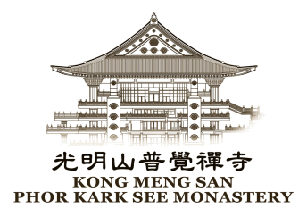  KMS DHARMA SCHOOL  COMPASSION BURSARY / POCKET MONEY  2018 APPLICATION FORM  CLOSING DATE : 30 April 2019 | KONG MENG SAN PHOR KARK SEE MONASTERY  88 Bright Hill Road S (574117)  Tel : 68495351 Fax : 64526341  Email : counselling.services@kmspks.org

OBJECTIVES
- To help KMS Dharma School students from low income background to have the ability to continue their study.
- To provide pocket money for successful students who have received our bursary to buy food at school tuckshop during recess time.
- To sponsor talented students from low income background to attend courses.

ELIGIBILITY CRITERIA

- Applicants must be Singapore Citizen/Permanent Resident.
- Students of kms Dharma School. (Student must be still studying in the Dharma School at the point of applying
and while receiving the bursary.)
- Applicants must be currently studying in a government school or educational institution or independent
school, not including private school.
- Applicants who come from household monthly gross income of less than or equal to S$2,500.
- Applicants should not be receiving any other bursary schemes.
- Applicants must be staying in HDB flats of not more than 4 rooms, or other accommodation of same or
worse conditions.

APPLICATION
Interested applicants may obtain the application form from Kong Meng San Phor Kark See Monastery’s Reception Office. The duly completed application form, together with the required documents must reach the following address on or before the stipulated date. Late or incomplete applications will not be considered.

KMS Counselling & Social Services
Kong Meng San Phor Kark See Monastery
88 Bright Hill Road
Singapore 574117

The following documents must be attached together with the application form:
a) a copy of the student’s latest academic school examination result slip;
b) a certified copy of parents’/guardian’s and students’ Identity card or birth certificate;
c) latest income pay slips of the parents/guardian;
d) copies of all banks’ pass books, and
e) the latest CPF statement.
f) Separation/Divorce letter or Death Certificate of spouse
g) Statements’ of other bursaries that applicant or applicant’s parent/guardian is currently receiving from or in process.

AWARD SYSTEM
- Awards are given to: i) Primary school students & ii) Secondary school students.
- The selection board will decide the award recipients within a month after the closing date.
- Applicants should possess good conduct and be recommended by their Dharma School teacher.
- Families suffering from sudden hardship or loss of income from sole breadwinner will get the priority.

SELECTION
Applicants and their parents/guardian who are qualified are required to appear for an interview. The decision shall be final and no correspondence on the matter will be entertained.
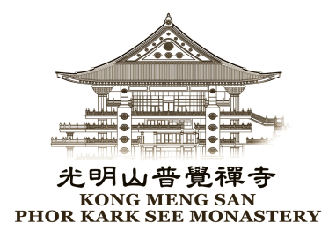  光明山少儿佛学班 - 慈心助学金 - 2019年报名表格  (截止日期 ： 2019年4月30日) | KONG MENG SAN PHOR KARK SEE MONASTERY  88 Bright Hill Road S (574117)  Tel : 68495351 Fax : 64526341  Email : counselling.services@kmspks.org  Email : sundayschool@kmspks.org

宗 旨
1) 帮助来自低收入家庭的光明山少儿佛学班的学童继续他们的学业。
2) 为领取本寺助学金的学童提供零用钱，让他们在休息时间在学校食堂购买食物。
3) 资助有才华的贫困学童报读校外课程（如音乐课、绘画课等）。

申 请 资 格
- 新加坡公民或新加坡永久居民。
- 在本校就读 (目前及领奖时还是在本校就读的学生)。
- 目前于一间政府学校或教育学府或自主学校，不包括私人学府。
- 家庭每月总收入是 S$2,500 或以下。
- 申请者不应是其他助学金计划的领受者 。
- 申请者必须居住在四房式或更小型的政府组屋，或条件一样或更差的其他房屋里。

申 请 方 法
请于向光明山普觉禅寺接待处索取申请表格。填妥后的申请表格须在以上指定的截止日期或之前送达光明山普觉禅寺。恕不接受逾期提交或不完整的申请表格。
呈交表格时，必须附上以下文件：
- 学生前年学校年终考试成绩表的确实副本，
- 家长/护人和学生的身份证 (I/C) 或出生报的影印本，
- 家长/监护人最新的收入发单，
- 所有有关的银行存折，
- 最新的公积金发单，
- 分居/离婚信件或伴侣的死亡证书，
- 其他助学金的文件或获取其他善款的文件。

颁 发 考 量 因 素
- 款项将颁发给：1〕小学生 及 2〕中学生。
- 遴选委员会将在截止日期后的一个月内决定领取者名单。
- 申请者应拥有良好品行，并获得光明山少儿佛学班老师的推荐。
- 突然陷入困境或丧失家中唯一收入来源的家庭将优先获得考虑。

遴 选
符合资格的申请者和其家长或监护人必须出席遴选委员会的面试。委员会的决定将是最后决定，恕不接受任何事后询问。

